**Name: Daniel Solitaria**

21 Find the total salary per position_id.

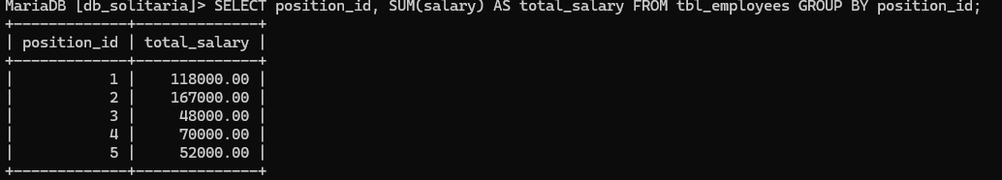

1. Show position_id groups having more than **1 employee**.

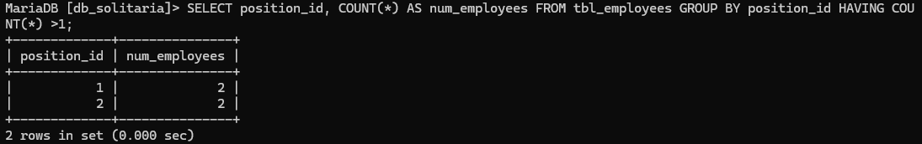

1. Show gender groups where the average salary is above **60,000**.

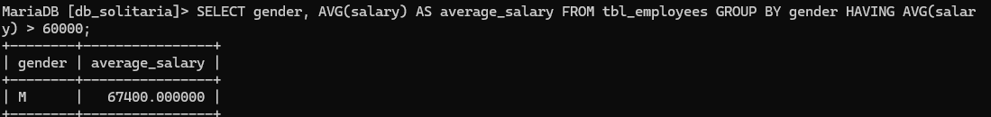

1. Show only the **first 3 employees** from the table.

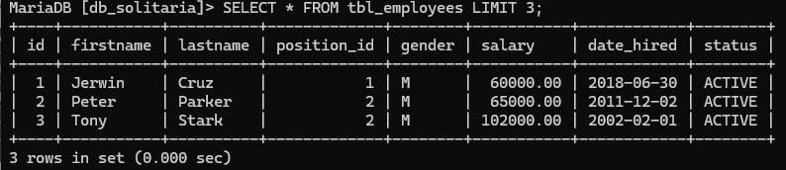

1. Show **3 employees starting from the 3rd record** in the table.

